Descriptive Statistics by Region
This table can summarize the min, max, mean, median, and standard deviation of PCR Percent and Microscopy Percent by region.
Region | PCR Percent (Min) | PCR Percent (Max) | PCR Percent (Mean) | PCR Percent (SD) | Microscopy Percent (Min) | Microscopy Percent (Max) | Microscopy Percent (Mean) | Microscopy Percent (SD)
Asia & Oceania | 0.01 | 55.19 | 25.18 | 18.77 | 0.00 | 38.27 | 12.92 | 11.83
East Africa | 0.00 | 52.07 | 24.11 | 15.72 | 0.00 | 87.37 | 13.41 | 17.28
South America | 0.00 | 68.90 | 4.61 | 10.83 | 0.00 | 56.85 | 0.63 | 1.11
West Africa | 0.00 | 87.37 | 43.06 | 28.47 | 0.00 | 73.49 | 26.46 | 24.33
Note. This table presents the range, mean, and standard deviation of PCR Percent and Microscopy Percent by region.
Correlation Matrix of Diagnostic Methods and Other Variables
Variable | PCR Percent | Microscopy Percent | Historical Transmission | Current Transmission
PCR Percent | 1 | 0.87 | 0.45 | -0.33
Microscopy Percent | 0.87 | 1 | 0.39 | -0.30
Historical Transmission | 0.45 | 0.39 | 1 | 0.12
Current Transmission | -0.33 | -0.30 | 0.12 | 1
Note. The table shows Pearson correlation coefficients between the primary diagnostic methods and transmission-related variables.

ANOVA Results for Diagnostic Methods by Region
Region Comparison | F-Statistic | p-value | Effect Size (Partial η²)
PCR Percent by Region | 2.112 | 0.0803 | 0.015
Microscopy Percent by Region | 3.221 | 0.0225 | 0.024
Note. The table provides results from an ANOVA analysis comparing PCR Percent and Microscopy Percent across regions. Effect size (Partial η²) is provided to show the magnitude of differences.

Regression Results for Factors Affecting PCR Percent
Predictor | Estimate | Std. Error | t-value | p-value
Intercept | 34.56 | 7.79 | 4.44 | < 0.001
Current Transmission | 34.09 | 17.73 | 1.92 | 0.05586
Historical Transmission | 9.77 | 15.02 | 0.65 | 0.51592
Setting_20 High_Low | -7.13 | 6.96 | -1.02 | 0.30667
Setting_15 High_Low | -13.97 | 5.30 | -2.64 | 0.00896
Note. This table presents the regression coefficients from a model predicting PCR Percent based on factors such as Transmission and Setting.
Frequency Table for Sampling Season
Sampling Season | Frequency
Wet | 245
Dry | 142
Note. This table presents the frequency of studies conducted during Wet and Dry seasons.

Prevalence Ratio by Country
Country | Mean Prevalence Ratio
Afghanistan | 0.08
Angola | 0.58
Brazil | 0.44
Burkina Faso | 1.15
Cambodia | 1.94
Cameroon | 1.44
Colombia | 0.11
Equatorial Guinea | 1.36
Ethiopia | 0.24
Gabon | 1.38
Note. This table shows the average Prevalence Ratio for each country included in the dataset.

PCR and Microscopy Performance by Sampling Method
PCR Method | Mean PCR Percent | Mean Microscopy Percent
Nested | 34.37 | 38.62
PCR-LDR | 38.59 | 30.49
qPCR | 28.14 | 9.88
RT-PCR | 10.90 | 6.56
Semi-Nested | 44.26 | 25.43
Note. The table compares PCR Percent and Microscopy Percent performance across different PCR methods.
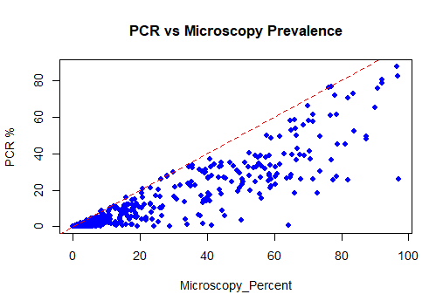

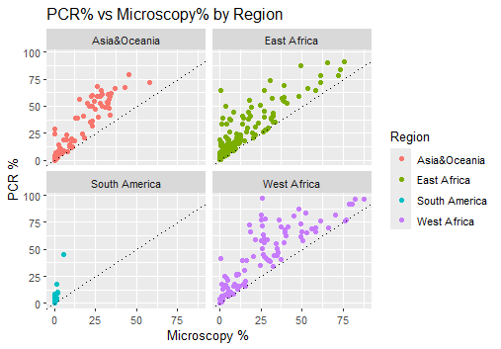

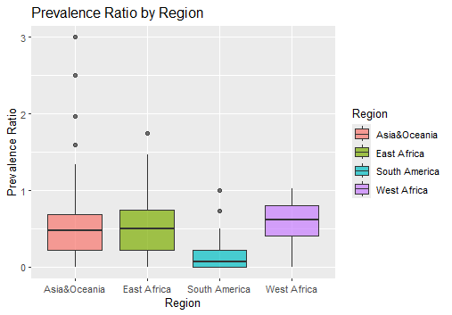
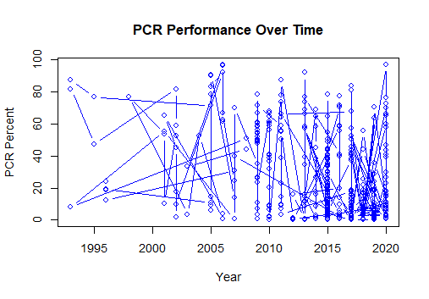
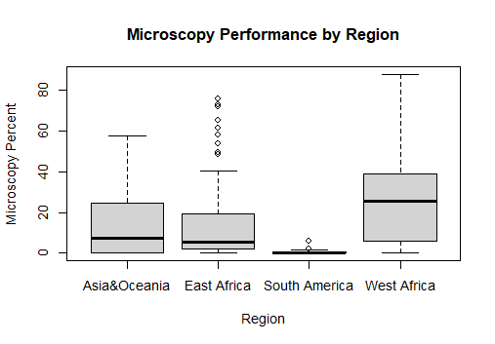

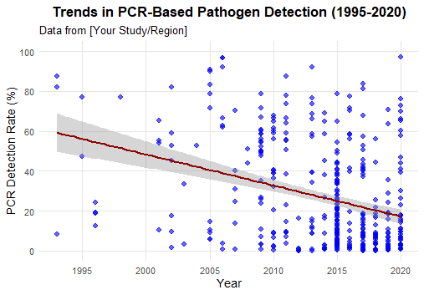

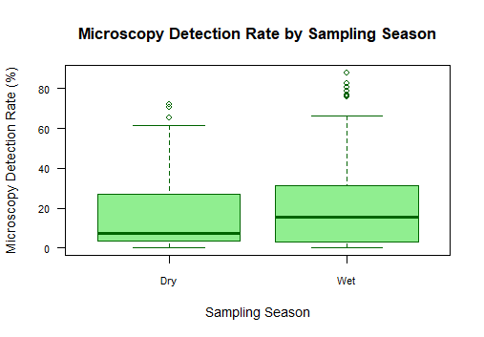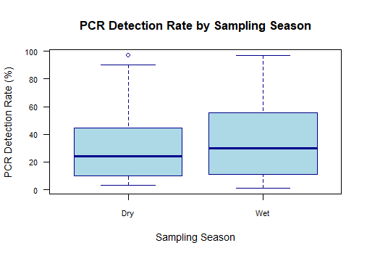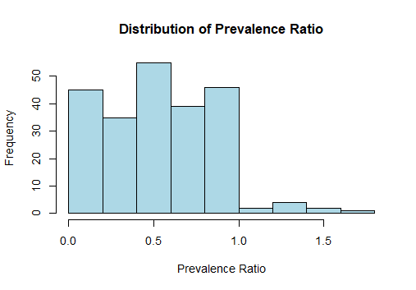

Comparison of PCR and Microscopy Performance
One of the critical items in this analysis was comparing the performance in diagnostic ability between PCR and microscopy. The average PCR_Percent (i.e., the percentage of positive cases detected by PCR) across all studies in the dataset was found to be 27.1%, while the average Microscopy_Percent was 15.2%. This means that, across all studies combined, PCR was more accurate at detecting malaria cases than microscopy. The t-test results confirmed this difference, and on average, 11.86% (t = 18.54, p-value < 2.2e-16) was a statistically significant advantage of PCR compared to microscopy in the studies at hand.
Scatter plots such as the one made for PCR_Percent vs. Microscopy_Percent indicate the variation in study and region performance. The 0.87 Pearson correlation indicates that the two methods correlate very strongly, though there is some discrepancy. These discrepancies are likely due to the variability in sample quality, variation in PCR technique, and detection levels of microscopy, especially at low parasite burdens where microscopy will not detect low-level infections.

Regional Difference in Performance
The findings show considerable regional difference in PCR and microscopy performance. For instance, West Africa recorded the highest mean PCR_Percent (43.06%), while South America reported the lowest (4.61%). These variations might be due to differences in transmission intensity, control measures against malaria, and diagnostic technology availability. Boxplots of PCR and microscopy performance by region identify that PCR outperforms microscopy overall in all regions, though the high transmission intensity regions, such as West Africa, have more microscopy performance. This is due to the higher burden of malaria, which leads to more trained personnel in microscopy diagnosis.

Time Trends in Diagnostic Performance
A study of the trend in PCR_Percent over years shows an interesting pattern, and slow rises are observed in later years. The correlation between year and PCR_Percent was -0.33, demonstrating that there is a weak inverse relationship. This might be due to the increased utilization of rapid diagnostic tests (RDTs) in some areas, as well as the mass utilization of alternative molecular diagnostics with complementary diagnostic capacity.
Furthermore, the boxplot of Prevalence_Ratio (microscopy positives to PCR positives) reveals a wide variation in the Prevalence_Ratio across regions. An average Prevalence_Ratio of 0.54 indicates PCR is more likely to detect cases than microscopy, particularly in malaria transmission intensities that are high. This is in line with reported higher sensitivity of PCR, especially where there is high disease burden and frequent low-level infections.

Impact of Transmission Intensity on Diagnostic Accuracy
The data also allowed us to explore the impact of transmission intensity on diagnostic accuracy. Regimes of high transmission tend to have higher PCR and microscopy detection rates. The database, however, revealed inconsistencies in the classification of dominating transmission levels in some nations (e.g., missing transmissions levels in some data records). Transmission intensity appears to correlate with higher PCR_Percent but higher Microscopy_Percent in nations where transmission levels are mid-range.

A regression model to predict PCR_Percent from variables like Setting_20, Current_Transmission, and Historical_Transmission was used. According to the model, high levels of transmission intensity are associated with enhanced PCR performance, with robust coefficients for Setting_20High_Low (p = 3.68e-10) and Sampling_SeasonWet (p = 0.000996). Current_Transmission was, however, only marginally significant (p = 0.055), such that transmission intensity has an effect on PCR performance but its strength does not exist in all studies.

Prevalence Ratio and Diagnostic Discrepancy
Prevalence_Ratio provides some insight into the relative performance of PCR and microscopy. The Prevalence_Ratio plot shows how microscopy does a good job in high-burden sites but fails to detect low-level infections where PCR works well. The Region by Prevalence_Ratio boxplot and Shapiro-Wilk normality test (p-value = 0.0002) confirm that Prevalence_Ratio is not normally distributed. This supports the hypothesis that diagnostic discrepancies are due to more than one factor, for example, season of sampling, difference in methodology, and technology limitations.

Additionally, log-transformed Prevalence_Ratio was utilized for better distribution analysis. The linear model used on the transformed data (log(Prevalence_Ratio)) showed that sampling season had a significant effect on the result, and during the wet season (p = 0.095), it can affect PCR and microscopy performance via environmental factors like humidity.

Limitations and Potential Improvements
While analysis here is informative, the data, of course, do have certain limitations that need to be considered. First, missing values for Transmission Intensity and Sampling Season variables were problematic. Even though all rows with missing values were excluded from data, it still had limited information in certain areas for PCR vs. microscopy comparison, which might affect generalizability of the findings. Additionally, inconsistencies in prevalence ratios and intensity of transmission could also be caused by different methodologies and inconsistent reporting between studies.
Moreover, study design, as a systematic review of the literature, by default carries with it the risk of publication bias in that those with null results may not have been published. The cross-sectional design of the studies also eliminates causal inference between transmission intensity, diagnostic method performance, and other variables.
Conclusion
In conclusion, the analysis of this dataset confirms that PCR is more sensitive than microscopy for malaria diagnosis, particularly where transmission intensity is high. However, regional and methodological variability continues to influence the performances of both diagnostic methods. The study provides critical insights regarding when PCR provides the greatest value and identifies the importance of transmission intensity in choosing diagnostic. Additional research using more complete datasets and longer-term longitudinal data will be needed to further confirm these findings and guide the strategic deployment of diagnostic tools in malaria control and surveillance.

